Linked Lists
Objectives
The objective of this session is to use a linked list to reimplement the word sorting code completed in the Searching and Sorting practical. This code was slow because the word array needed to be resorted after each insertion. This is not necessary with a linked list since the insertion point maintains the ordering of the list.
Reference Material
The material is based entirely on the Linked List chapter. Solutions and code templates are provided in the linklist directory.
Overview
There are two source files to consider, the first is storint.c which contains all the code from the chapter and implements a singly-linked list of integers. The other file to consider is freq.c which contains code to prompt for a file, open it for reading and break it into words.
Practical Outline
In the freq.c file, examine the process() function which breaks the input file into separate words. Each word from the file is read via the getNextWord() function into a character array. Build up a linked list of words using the code in storint.c. Don’t put a fixed size character array into the nodes, instead use a char* and dynamically allocate the storage for each new word.
Thus, the four words “how now brown cow” would build a list as follows:
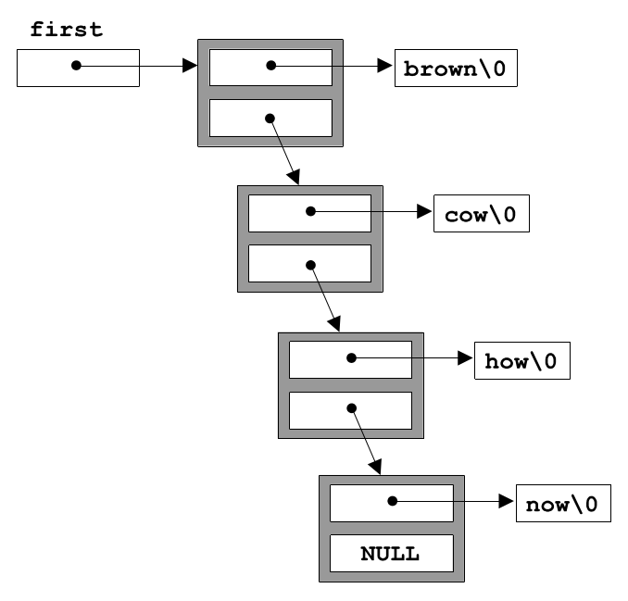
You can use the text file long.txt as trial input. When you have the code working you might like to incorporate the timing routines from the arrays practical.
You should find the program is noticeably quicker than the equivalent from the Sorting and Searching practical in which the array was resorted using qsort after each insertion.

